Small Business In-Branch Workshop Day 2
Date | 06/06/23 |  | Location | Edmonton
Time (From / To) | 13:00 to 15:00 Mountain Time |  | Facilitators | Angela Ahn & Dan Riberdy
Attendees
CWB |  | Accutive
- Candyse Watkinson  - Ian Hicks  - Ali Anwar  - Amelie Teodosio  - Kelvin Fernando  - Fusi Olateru  - Chris Monita |  | - Angela Ahn  - Dan Riberdy (meeting organizer)  - Sampada Deshpande  - Blake Hunter  - Lucy Liu  - Neil Vany

Objectives:

- Gather and finalize requirements for Small Business In-Branch

Discussion Notes

In the workshop today we discussed and reviewed the following:

Small Business Process Flows

- Application Flow No Authorized Signers
- Application Flow with Authorized Signers (All On-site) (covered in D)
- Applicant Flow with Authorized Signers (None-On-site) (covered in D)
- Applicant Flow with Authorized Signers (Some On-site)

Application Flow No Authorized Signers

- Landing page
Needs to be amended to include the Business vs. Personal radio buttons and conditional checklists

- Let's get started page
If pre-search in the background returns with non-existant or inactive business, need some popup modal to inform applicant & provide a way to go back and change registration or other info and try again
Can't proceed to Next page until that's resolved

- About the business page
Pre-filled by COVR or manual entry

- More about the business page
Redundancy around entity types between this page and Let’s get started

- Upload Ownership Documents page
- Upload business verification documents page
Need to upload at least one of each for T24 onboarding
Combine both doc pages into one?
Need to be able to upload multiple documents of each type?
Obtain hard copies in-branch vs. upload them

- Select Account(s) page

- Business Associates page

- About the new account(s) page

- Debit card and online banking access page

- Business DCO Process Complete page

Applicant Flow with Authorized Signers (Some On-site)

- Landing page

- Let's get started page

- About the business page

- More about the business page

- Upload Ownership Documents page

- Upload business verification documents page

- Select Account(s) page

- Business Associates page
NEW! need a "Send self-serve invitation" checkbox for clients not present in the branch
"Send self-serve invitation" checkbox within the card or not (i.e. template change?) - TBD

- Onboard new applicants page (cycle through these for each 'in-branch' applicant whom didn't already have an existing CIF)
- Applicant x address page
- Applicant x dob, sin & occupation
- Applicant x Inbranch customer information (Idv + bureau Y/N)
- DCO Decisioning
- Business DCO Inbranch Process Complete (wait here for applicants not in-branch to complete their process)
Note: Applicants who are not in-branch get their email and their application process is the same as the SB SS authorized signers flow
When complete, an email is sent to the staff who created the app with a cc: to the branch's general email inbox
- Company ABC associates are now complete page

Need a summary page here to show all applicant's beacons and key info?

- About the new account(s) page

- Debit card and online banking access page

- Business DCO Process Complete page

Per Kelvin – flow mock-ups for Business In-Branch
The Barbershop (Single application)
⁠Savory Bites (Inbranch)
⁠Savory Bites (Remy)
⁠Savory Bites (Staff completing the application)

Per Amelie - T24 DCO Channel code

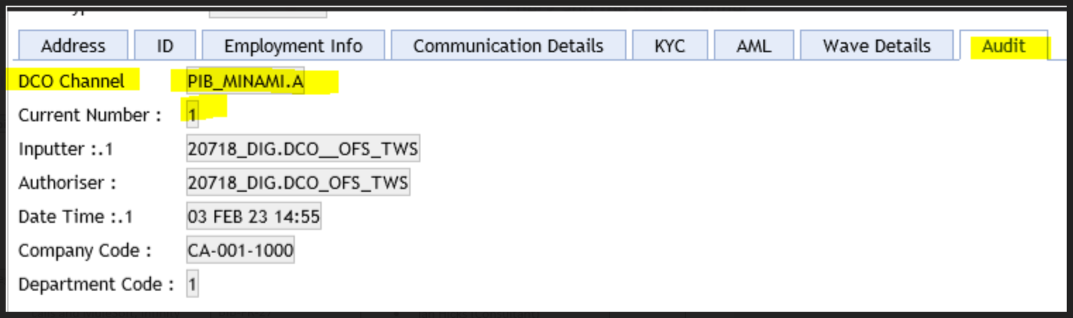

Action Items

# | Action Items | Responsible
1 | How can we resume an application?  Can we disable the 'token' needed to launch a saved application | Lucy
2 | Can we add a summary page with each applicant’s CIF, beacon, idv?, etc. | Sampada
3
4
5
6
7
8
9
10
11

